WATER TESTING

Acidity and Alkalinity

• Place 5 mL of each water sample in a clean test tube.
• Test for pH using either of the following.

• pH meter - records directly.
• 3 drops of universal indicator - compare the colour of the solution with the chart.

pH Scale 0 7 14
strong acid neutral strong alkaline
(red) (green) (purple)

WATER SAMPLE | pH | LEVEL OF ACIDITY / ALKALINITY

Sulphate Ions (SO₄²⁻)

• Place 5 mL of each water sample in a clean test tube.
• Add 5 drops of barium chloride (BaCl₂) to each test tube.
• If a white precipitate (solid) forms, it contains sulphate ions.

WATER SAMPLE | SOLID  (yes/no) | LEVEL OF SULPHATE

Chloride Ions (Cl¹⁻)
CONCENTRATION (parts per million) | CONDUCTIVITY (milli Sieverts)
2500 | 4.5
1500 | 2.9
1000 | 2.0
800 | 1.5
600 | 1.1
400 | 0.7

• Place 5 mL of each water sample in a clean test
tube.
• Use either of the following methods for testing.

• Conductivity meter - use the scale at right.
• Add 5 drops of silver nitrate (AgNO₃) -
compare to the standard test tubes.

If a white precipitate (solid) forms, it contains chloride ions.

WATER SAMPLE | CONCENTRATION (parts per million)

Phosphate Ions (PO₄³⁻)

• Place 5 mL of each water sample in a clean test tube.
• Add 5 drops of silver nitrate (AgNO₃) to each test tube.
• If a yellow precipitate (solid) forms, it contains phosphate ions.

WATER SAMPLE | SOLID  (yes/no) | LEVEL OF PHOSPHATE
Lead ions (Pb²⁺)

• Place 5 mL of each water sample in a clean test tube.
• Add 5 drops of acidified potassium chromate (K₂CrO₄) to each test tube.
• If a yellow precipitate (solid) forms, it contains lead ions.

WATER SAMPLE | SOLID  (yes/no) | LEVEL OF LEAD

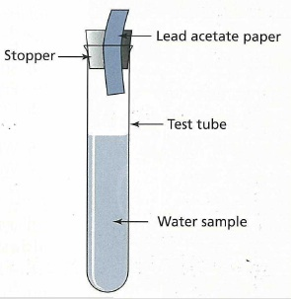
Hydrogen Sulphide (H₂S) Gas

• Place 5 mL of each water sample in a clean test tube.
• Use a stopper to hold lead acetate paper above the liquid.
(Use forceps to handle the paper - don't touch it!)
• If the paper turns black, the water contains hydrogen
sulphide.

WATER SAMPLE | AMOUNT OF H₂S  PRESENT

Ammonia (NH₃) Gas

• Place 5 mL of each water sample in a clean test tube.
• Place a piece of turmeric paper in the water.
• If the paper turns reddish-brown, the water contains ammonia.

WATER SAMPLE | AMOUNT OF NH₃  PRESENT

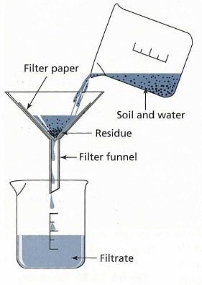
Suspended Materials

• Filter 20 mL of the water through a fine filter paper.
• Let the paper dry.
• Use a hand lens or stereo microscope to observe any trapped
solids.

WATER SAMPLE | SOLID  (yes/no) | DESCRIPTION OF SOLIDS

Turbidity
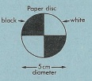
• Place 50 -100 mL of the water in a tall clear glass tube
(gas jar, measuring cylinder,etc).
• Place a black and white turbidity disc under the
bottom.
• Look at the disc through the water.
• If the disc is easily seen, it has low or no turbidity.
If it is difficult to see, it has a moderate to
high turbidity.

WATER SAMPLE | AMOUNT OF TURBIDITY

